KWAME NKRUMAH UNIVERSITY OF SCIENCE AND TECHNOLOGY
COLLEGE OF SCIENCE
FACULTY OF PHYSICAL AND COMPUTATIONAL SCIENCE

PROJECT DOCUMENTATION
BACHELOR OF SCIENCE (BSc) COMPUTER SCIENCE PROGRAMME
PROJECT TITLE:
Institutional Accountability and Resource Tracking System (IARTS)
A Web-Based Platform for Attendance-Verified Fund Disbursement in Government-Funded School Feeding Programmes
SUBMITTED BY
Essandoh Prince Takyi
Reference Number: 20940308 | Index: 3390922
Haruna Bawumia Fahad
Reference Number: 20939596 | Index: 3393222
Supervisor: Dr. Agyemang

CHAPTER ONE
INTRODUCTION

1.1 Introduction
Government-funded education programmes play an important role in extending equal access to education, covering costs such as meals, teaching materials, and other essential resources. In Ghana, initiatives such as the Free Senior High School (Free SHS) programme have significantly increased enrolment and reduced the financial burden on families. Efficiently managing the funds behind these programmes, however, remains a major challenge: most schools still rely on manual, paper-based headcounts to determine how many meals were served and how much a supplier should be paid, with no independent way to confirm those figures before public money moves.

1.2 Problem Statement
Manual record-keeping makes it difficult to accurately verify how many students were actually served, monitor the use of government-funded resources, and ensure that public funds are released based on real participation rather than a reported figure. Because attendance verification and fund disbursement are handled as two disconnected steps, whoever compiles the attendance report has both the opportunity and, given how funding is tied to reported numbers, the incentive to inflate it — and nothing downstream cross-checks the claim against actual attendance before money is released. The result is a consistent risk of inflated headcounts, misused resources, and financial losses to the state. This project addresses that gap by proposing the Institutional Accountability and Resource Tracking System (IARTS), a centralized platform that ties government fund disbursement directly to independently verified student attendance.

1.3 Aim of the Project
The main aim of this project is to design and implement IARTS, an automated attendance verification and resource tracking system for government-funded school feeding programmes, enabling accurate verification of student attendance, secure fund disbursement, and full transparency and accountability in the allocation of public education funds.

1.4 Specific Objectives of the Project
- To design and develop a centralized student attendance verification system built around QR-enabled dining cards.
- To generate a secure, unique QR identification code for every enrolled student.
- To capture and monitor meal attendance in real time at the point of service.
- To implement a token-based workflow that ties government fund disbursement directly to verified attendance reports.
- To implement role-based access control for school, government, supplier, and bank stakeholders.
- To generate automated, audit-ready reports to support fund disbursement decisions.
- To reduce fraudulent reporting and resource misallocation within participating schools.

1.5 Justification of the Project
Government-funded school feeding programmes require accurate, tamper-resistant data to ensure that public resources reach the intended beneficiaries without leakages. Traditional monitoring methods depend heavily on paper logs and manual reconciliation, which are slow, costly, and easy to manipulate. A centralized, digital verification and fund-disbursement system reduces inaccurate reporting, closes the gap between attendance and payment, and supports evidence-based decision-making. This project is justified because it offers an automated, scalable technological solution that strengthens public confidence in the management of national education funds.

1.6 Motivation for Undertaking the Project
The motivation behind this project comes from the need to improve transparency and efficiency in managing high-impact, government-funded feeding programmes. Existing administrative processes are vulnerable to manual error and lack the integration needed for real-time monitoring. Advances in web development, secure database systems, and identity management create a practical opportunity to build an automated platform that closes the gap between verified attendance and fund disbursement — a real socio-economic challenge affecting the national education sector.

1.7 Scope of the Project
This project focuses on developing IARTS as a centralized attendance-verification and fund-disbursement platform for government-funded school feeding programmes. The functional scope includes student registration and QR dining-card issuance, dining-hall attendance verification, daily and weekly report generation, a government token issuance and approval workflow, supplier token redemption, and bank-side token validation and payment release.
The project does not cover real-time integration with national identity databases or existing banking core systems; these external dependencies are simulated within the system environment for demonstration purposes.

1.8 Project Limitations
- Access to real, live government educational datasets may be restricted by data-privacy policy, so development and testing rely significantly on simulated data patterns.
- Time constraints within the academic calendar limit the scope of long-term pilot testing.
- Direct integration with live national or banking systems (such as the National Identification Authority) is not possible during development and is represented with simulated API behaviour instead.

1.9 Beneficiaries of the Project
- The Ministry of Education (MoE) and Ghana Education Service (GES), who require reliable data for funding allocations.
- School Administrators, who gain an efficient tool for managing student and attendance records.
- Food Suppliers and Participating Banks, who gain a transparent, auditable token-to-payment workflow.
- Auditors and Policymakers, who obtain clear, transparent audit trails to verify fund utilisation and design better policy.
- Students, who benefit from a more equitable and reliable school feeding service.

1.10 Academic and Practical Relevance of the Project
Academically, this project contributes to Software Engineering, Database Management Systems, and Information Security by demonstrating how role-based, token-driven architecture can be applied to a real public-sector accountability problem.
Practically, the project gives educational authorities a mechanism to detect and reduce resource leakage faster than manual tracking allows, lowering administrative overhead while increasing accountability over publicly funded programmes.

1.11 Project Activity Planning and Schedule
The project was organised across sequential development phases over a 14-week timeline.
Activity | Duration
Topic Selection and Proposal | Week 1 – Week 2
Literature Review and Background Study | Week 3 – Week 4
System Analysis and Requirements Gathering | Week 5 – Week 6
System Design and Database Architecture | Week 6
Core System Development and Coding | Week 7 – Week 10
System Testing, Debugging, and Validation | Week 11 – Week 12
System Documentation and Report Writing | Week 13
Final Project Review and Presentation | Week 14

1.12 Structure of the Report
This report is organised into five chapters:
- Chapter One presents the introduction, problem statement, aims and objectives, justification, motivation, scope, limitations, and significance of the project.
- Chapter Two reviews existing approaches to school feeding attendance and fund disbursement, identifies their gaps, and presents the proposed system, IARTS, including its architecture and components.
- Chapter Three details the system methodology: requirements, stakeholders, UML models, non-functional requirements, security concepts, the chosen project method, and the UI and database designs.
- Chapter Four presents the system implementation: the development environment, database, backend and frontend construction, integration, security, and testing.
- Chapter Five presents the findings, conclusions, limitations encountered, lessons learnt, and recommendations for future work and commercialisation.

1.13 Project Deliverables
The final deliverables of this project include:
- A fully functional web-based Institutional Accountability and Resource Tracking System (IARTS).
- A secure relational database populated with the relevant system schema.
- The complete application source code, with documentation and deployment files.
- Comprehensive system design diagrams, including Entity-Relationship Diagrams (ERDs) and Unified Modeling Language (UML) models.
- System testing results evaluating functionality, role-based security, and data consistency.
- A comprehensive final project report detailing system design, implementation, and evaluation.

CHAPTER TWO
REVIEW OF RELATED WORKS

2.0 Introduction
This chapter reviews the categories of systems currently used to manage school feeding attendance and disburse public funds tied to that attendance, identifies the gaps in these approaches, and presents the design of the proposed system — the Institutional Accountability and Resource Tracking System (IARTS). It covers the conceptual design, system architecture, component descriptions, proposed features, development tools and environment, and the expected benefits of the system.

2.1 Processes of Existing Systems
School feeding and dining hall funding programmes typically rely on one or a combination of the following approaches to determine how many meals were served and how much a supplier or institution should be paid. Each is reviewed below in terms of its features and its strengths and weaknesses.

2.1.1 Manual / Paper-Based Headcount and Reimbursement Systems
Dining hall staff or class prefects record the number of students served at each meal in a logbook or attendance sheet. At the end of a reporting period, the school compiles these figures into a report and submits it to the funding body, which reviews the figures and authorises payment to the supplier.
- Features: paper registers or spreadsheet-based headcount logs; manual reconciliation by an administrator; periodic, not real-time, reporting.
- Pros: requires no special hardware or technical skill; very low setup cost; familiar to school staff.
- Cons: headcounts are self-reported and cannot be independently verified; no audit trail beyond a signature; slow reconciliation means fraud surfaces (if at all) only after payment; and “meals served” and “cash released” are approved as two disconnected steps.

2.1.2 RFID / Barcode-Based Cafeteria Management Systems
Common in universities and some boarding schools, these systems issue a card or barcode to each student, scanned at the dining hall entrance, sometimes deducting a meal credit from the student's account.
- Features: card- or barcode-based identity check; digital, exportable scan log; sometimes integrated with a prepaid meal-credit wallet.
- Pros: faster and more reliable than a paper headcount; produces a timestamped digital record; reduces queue time and counting errors.
- Cons: built for operational tracking, not financial accountability — the scan data rarely feeds into a funding decision; nothing stops a school reporting a different figure than the scan log shows; typically siloed to one school with no government, bank, or supplier visibility; duplicate or proxy scans often go unflagged.

2.1.3 Biometric Attendance Systems
Fingerprint or facial-recognition devices verify a student's identity before granting dining hall access, primarily to curb card-sharing abuse.
- Features: biometric identity verification at the point of service; digital attendance log per student, per meal.
- Pros: strong identity assurance, much harder to defraud than a card swipe; reliable, individualised attendance data.
- Cons: expensive hardware and higher maintenance overhead, difficult to scale across many schools; attendance data is typically consumed only by the school itself; no end-to-end chain connecting verified attendance to token issuance to cash release, so financial fraud risk at the reporting stage remains even though attendance is verified.

2.1.4 Mobile Money / Direct E-Payment Disbursement Systems
Funding bodies disburse money electronically — via mobile money or bank transfer — directly to suppliers or schools based on submitted headcount reports, replacing cash or cheque payments.
- Features: digital, traceable payment rails; faster disbursement than manual cheque processing.
- Pros: removes cash-handling risk and speeds up payment; creates a payment audit trail.
- Cons: solves the payment problem but not the verification problem — the amount paid is still based on a self-reported or loosely audited headcount; fraud simply shifts earlier in the pipeline, since the payment rail will faithfully disburse against an inflated figure.

2.1.5 Summary of Gaps in Existing Systems
Across all four categories, the common gap is the same: attendance verification and fund disbursement are treated as two separate, loosely-coupled processes. The table below summarises each system type against four accountability criteria.
System Type | Verifies Identity? | Real-Time? | Tied to Fund Release? | Multi-Stakeholder Visibility?
Manual / paper headcount | No | No | Loosely (manual approval) | No
RFID / barcode cafeteria | Card-level | Partial | No | No
Biometric attendance | Strong | Partial | No | No
Mobile money disbursement | No | No | N/A (pays on report) | Payment only
Whoever compiles the attendance report has the opportunity — and, given how funding is tied to reported numbers, the incentive — to inflate it, because nothing downstream cross-checks the claim against actual verified scans before money moves. This is the specific gap IARTS is designed to close.

2.2 The Proposed System
IARTS is proposed as a government-grade platform that removes financial fraud in school dining hall funding by tying supplier payments directly to verified student attendance data, rather than to a self-reported figure. The system enforces one governing rule throughout the entire fund-release pipeline:
No verified attendance = no token = no cash released to the supplier.
Instead of a school submitting a headcount that a funding body simply trusts, IARTS requires every meal to be backed by a physical card tap at the dining hall. These taps generate an attendance report that only the government can convert into a redeemable token, which the supplier must submit to a bank before any cash is released. Every step is visible to the party responsible for the next step, closing the reporting/verification gap identified in Section 2.1.

2.3 Conceptual Design
IARTS is built around five actors, each with a distinct, non-overlapping responsibility. No single actor can both generate and approve their own funding claim — a separation of duties that is the core fraud-prevention mechanism of the system.
Actor | Role in the System
Student | Has no portal or login. Participates only via a physical card tap at the dining hall scanner — removing any incentive or opportunity to falsify their own attendance.
School Admin | Manages student and card records, monitors the dining hall feed in real time, reviews fraud alerts, and compiles the daily meal report from actual scans, not an estimate.
Government | Reviews each school's submitted attendance report, cross-checks it against reported enrolment, and — only if satisfied — issues a monetary token to the relevant supplier.
Supplier | Receives tokens issued by the government, submits them to the bank for redemption, and logs food deliveries against fulfilled orders.
Bank | Independently validates each submitted token before releasing cash, and produces an audit trail of every transaction.

Conceptual Data Flow — The Token Chain
The diagram below illustrates the sequential flow of verified data from a student's card tap through to the final cash release. Because every stage consumes the verified output of the stage before it, a fraudulent claim introduced at any point has no valid scan data to support it and is rejected before money moves.
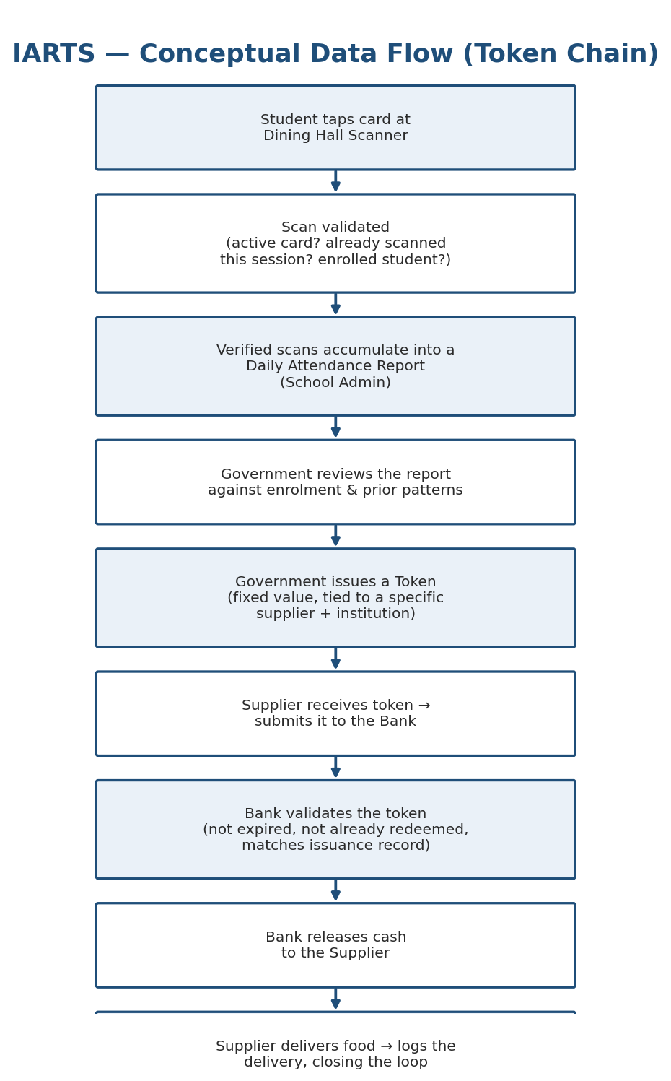
Figure 2.1: Conceptual Data Flow — Token Chain

2.4 Architecture of the Proposed System
IARTS follows a three-tier, role-partitioned client–server architecture, illustrated below.
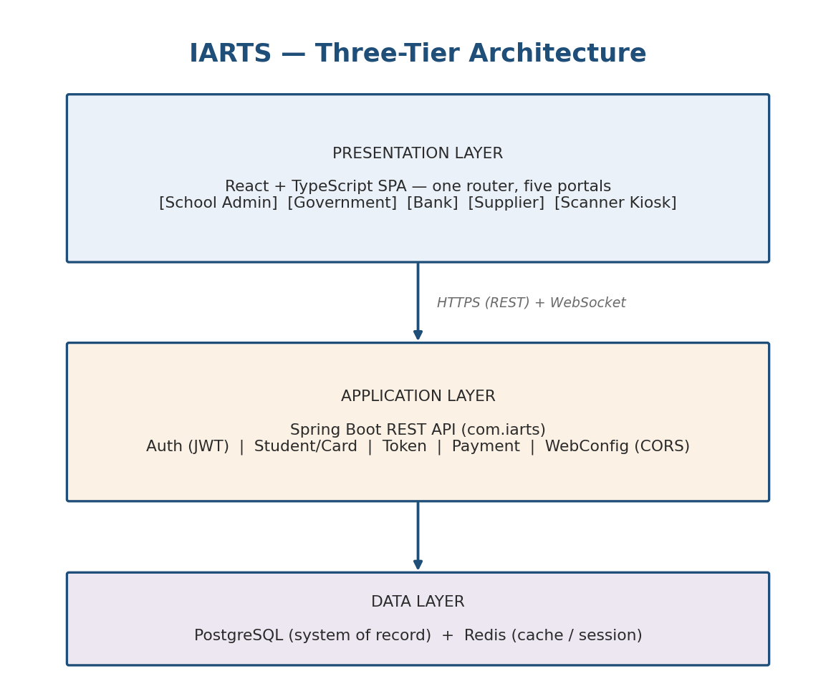
Figure 2.2: Three-Tier Architecture

Layer Descriptions

1. Presentation Layer
A single Vite/React/TypeScript application, role-routed (/admin, /gov, /bank, /supplier, /scanner) so each actor only ever sees the screens relevant to their role. State is managed with Zustand for auth/session data and TanStack Query for server-state caching, styled with Tailwind CSS. The Scanner Kiosk is deliberately excluded from the authenticated router — it runs as a public, browser-based QR scanning terminal authenticated only by a terminal key, since it must be usable at a physical dining hall counter without a student or staff login.

2. Application Layer
A Spring Boot REST API exposing endpoints grouped by domain: authentication (JWT-based), student and card management, token issuance and lifecycle, and bank payment processing. A WebSocket channel pushes live scan events from the dining hall to the School Admin portal's real-time feed without requiring a page refresh.

3. Data Layer
PostgreSQL persists all system-of-record data (students, cards, scans, reports, tokens, transactions). Redis is used for caching and short-lived session/state data such as terminal key validation and rate-limiting scan bursts. This layered separation means the frontend never has to trust client-side logic for anything financial — every token issuance and cash release decision is enforced server-side, and the presentation layer is purely a role-scoped view onto that state.

2.5 Component Designs and Component Descriptions
This section describes what each major component does and how it functions within the overall architecture; detailed algorithms for each component are presented in Chapter Four.

2.5.1 Dining Hall Scanner Kiosk
A browser-based, camera-driven QR card scanning terminal that operates with no user login, authenticating itself to the backend using a fixed terminal key rather than a user session. On each scan it sends the card identifier to the backend, which returns one of four outcomes — served, unknown card, duplicate scan, or inactive student — displayed instantly so dining hall staff can act on it without consulting a separate system. A 3-second cooldown prevents the same card from being submitted twice in quick succession.

2.5.2 School Admin Portal
Gives school staff a live dining hall feed reflecting card taps as they happen; student and card registry management, including issuing and deactivating dining cards; a fraud alert dashboard flagging anomalies such as duplicate or unusually-timed scans; daily meal report compilation drawn directly from verified scans rather than manual entry; and supply logging to track food deliveries against government-issued tokens. Daily reports move through a four-stage review pipeline — Generated, Operational Review, Compliance Review, and Claim Eligible — before becoming eligible for a government reimbursement claim.

2.5.3 Government Portal
Splits government oversight into role-scoped dashboards: a token issuance form for generating tokens linked to a specific supplier and institution, a claims workflow for reviewing and approving school reimbursement claims, a token ledger tracking every token ever issued, and a budget calculator for determining per-student funding allocations.

2.5.4 Supplier Portal
Gives food suppliers a token inbox, a submission workflow for sending tokens to the bank for redemption, a delivery logger, a full transaction history, and a reorder monitor that alerts a supplier when a school's stock of an item drops below the reorder threshold.

2.5.5 Bank Portal
Provides the final independent check in the payment chain: a pending-tokens queue, a token validation screen, a cash-release action enabled only after successful validation, a rejected-tokens log with recorded reasons, a full transaction log, and an audit report view for reconciliation.

2.5.6 Shared UI Component Library
A common set of reusable interface primitives — Badge, Button, Modal, DataTable, StatCard, DropdownMenu, and Icon — together with layout shells — DashboardLayout, PageHeader, and Sidebar — used consistently across all four authenticated portals, so every portal looks and behaves consistently without duplicating UI code.

2.5.7 Authentication and Authorisation Module
Issues JSON Web Tokens (JWTs) on successful login and enforces role-based route access both client-side, via router guards, and server-side, via a Spring Security filter chain that validates the JWT and role claim on every API request. The Scanner Kiosk bypasses user authentication entirely, authenticating instead with a terminal-specific key.

2.5.8 Token Lifecycle Module
Owns the state machine governing a government token from issuance to final settlement: Pending, Active, Submitted, Validated, Redeemed, Expired, and Rejected. The module enforces that a token can never be spent twice and cannot be accepted after its expiry date, regardless of what the requesting party claims.

2.6 Proposed System / Software Features
- Physical card-tap attendance capture at the dining hall — no self-reported headcounts
- Real-time dining hall scan feed visible to school administration as meals are served
- Automatic duplicate-scan and anomaly detection by the fraud engine at end of day
- Attendance-report-to-token issuance workflow, reviewable by government before approval
- Full token lifecycle tracking from issuance through submission, validation, and redemption
- Independent bank-side validation step before any cash is released to a supplier
- Four-stage report review pipeline (Generated → Operational Review → Compliance Review → Claim Eligible)
- Reimbursement claim workflow linking verified daily reports to government payment approval
- Supplier delivery logging tied to the government token that funded each order
- Low-stock reorder alerts visible to suppliers in real time
- End-to-end audit trail spanning all five actors, traceable from a cash release back to the underlying verified scans
- Role-based access control ensuring each actor sees only the screens and data relevant to their responsibility
- Mobile-accessible scanner kiosk compatible with tablet or dedicated terminal hardware

2.7 Development Tools and Environment
This section gives a brief overview of the tools and technologies selected for the implementation of IARTS.

Frontend
Tool / Library | Purpose
React 19 with TypeScript | UI framework and type-safe component development
Vite | Fast development server and production build tool
React Router v7 | Client-side routing with role-based route guards
Zustand | Lightweight global state management for auth/session data
TanStack Query (React Query) | Server-state caching, background refetch, and loading states
Axios | HTTP client for communicating with the Spring Boot API
Tailwind CSS v3 | Utility-first CSS framework for consistent, responsive styling
react-hot-toast | Non-intrusive notifications for scan outcomes and user actions
qrcode.react | QR code generation for student dining cards
BarcodeDetector API | Browser-native camera-based QR scanning for the kiosk terminal

Backend
Tool / Technology | Purpose
Java with Spring Boot | REST API framework organised by domain (auth, student, token, payment)
Spring Security + JWT | Authentication and role-based authorisation on every API request
PostgreSQL | Primary relational database for all system-of-record data
Redis | Caching and short-lived state storage (terminal keys, rate limiting)
WebSocket | Real-time push of live scan events to the School Admin portal
Maven | Backend build tool and dependency management

Tooling and Environment
Tool | Role
Visual Studio Code | Primary IDE for frontend development
IntelliJ IDEA | Primary IDE for backend Java development
Git and GitHub | Version control and collaborative code management
Figma | UI/UX design, translated directly into React components
Postman | API testing during backend integration
Vercel | Planned hosting for the React frontend
Render.com | Planned hosting for the Spring Boot backend API

2.8 Benefits of Implementation of the Proposed System
- Fraud prevention at the source: funding decisions are based on verifiable card-tap data instead of a figure any single party could inflate.
- Faster, more defensible audits: every cash release traces back through a token to a specific set of verified scans.
- Accountability without added burden on students: students participate only by tapping a card, with no portal, login, or extra process imposed on them.
- Separation of duties: no actor can both generate a funding claim and approve it.
- Real-time visibility: school administrators, government reviewers, suppliers, and banks all see the same underlying data as it happens.
- Reduced disbursement delay: a digital, end-to-end pipeline moves verified attendance to released cash far faster than a manual reporting-and-approval cycle.
- Scalable oversight: the same architecture extends to additional schools, suppliers, or banks without redesigning the accountability model.

CHAPTER THREE
METHODOLOGY

3.1 Chapter Overview
This chapter explains how the Institutional Accountability and Resource Tracking System (IARTS) was designed and built. It covers the system's requirements, the people who will use it, how those requirements were gathered, the development approach, and the design models — including the UML diagrams — that shaped the final system.
Most school management systems stop at student administration. IARTS goes further: it links attendance verification, government approval, supplier payment, and bank validation into one accountability chain, so that every cedi released to a food supplier is backed by proof that meals were actually served.

3.2 Requirement Specification
Requirements for IARTS were drawn from how government-funded school feeding programmes actually operate. The goal was simple: make sure supplier payments are only ever released against verified attendance, not paperwork alone. Requirements are grouped into functional (what the system does) and non-functional (how well it does it — security, performance, reliability, scalability).

3.2.1 Hardware Requirements
- Development: Core i5/Ryzen 5 or better, 8GB RAM (16GB recommended), 512GB SSD, stable internet
- Deployment: cloud server for Spring Boot, PostgreSQL database, Redis cache, HTTPS web server
- Operational: computers for School Administrators, Government Officers, Bank Officers and Suppliers; a tablet/kiosk with a QR scanner for the dining hall; QR-enabled student ID cards

3.2.2 Software Requirements
- Frontend — React 19, TypeScript, Vite, React Router, Tailwind CSS, Axios, Zustand, TanStack Query
- Backend — Java 21, Spring Boot, Spring Security, JWT, WebSocket
- Database — PostgreSQL, Redis
- Tools — VS Code, IntelliJ IDEA, Git/GitHub, Postman, Figma

3.2.3 Operational Requirements
At a high level, the system must be able to register students, issue QR dining cards, verify students at mealtime, flag duplicate scans, generate attendance reports, route those reports through government approval, issue secure payment tokens, let suppliers redeem tokens through participating banks, and produce audit reports for every transaction.

3.3 Stakeholders of the System
IARTS separates responsibilities across seven types of users so that no single person can control the whole payment process from start to finish — this is what keeps the system accountable.

3.3.1 Students
Students don't log in anywhere. Their only touchpoint is tapping a QR card at the dining hall scanner, which checks their identity, confirms they're enrolled, and makes sure the card hasn't already been used for that meal before recording attendance.

3.3.2 School Administrator
Registers and manages students, issues and replaces dining cards, watches attendance in real time, reviews fraud alerts, and prepares daily reports for government submission. Administrators can't approve payments or issue tokens — that stays with government.

3.3.3 Government Officer
Reviews attendance reports against enrolment records through the Government Portal, checks for anomalies, and — once satisfied — approves reimbursement and issues a payment token to the supplier. Officers can review and approve, but can't edit attendance data.

3.3.4 Food Supplier
Receives payment tokens through the Supplier Portal once a claim is approved, submits those tokens to a bank for redemption, and tracks deliveries, payment history, and token status.

3.3.5 Bank Officer
Performs the last check before money moves: validates that a submitted token is genuine, active, and hasn't been redeemed before. Valid tokens get paid out; anything expired, duplicated, or invalid is rejected and logged.

3.3.6 Dining Hall Scanner Kiosk
Runs on a terminal authentication key rather than a login. It scans QR cards, checks eligibility with the backend, and shows an instant result — recorded, duplicate, invalid, or inactive — with a short cooldown to stop repeat scans in the same session.

3.3.7 System Administrator
Handles the technical side: user accounts, system configuration, performance monitoring, backups, and security updates. No access to attendance records or payment approvals.
Table 3.1: Stakeholder Summary
Stakeholder | Primary Responsibility
Student | Verifies attendance by scanning a QR dining card
School Administrator | Registers students, manages attendance, generates reports
Government Officer | Verifies reports and issues payment tokens
Food Supplier | Delivers meals and redeems payment tokens
Bank Officer | Validates tokens and releases payments
Dining Hall Scanner Kiosk | Captures verified attendance records
System Administrator | Manages system configuration, users, and security

3.4 Requirement Gathering Process
Requirements came together through four complementary methods: a literature review of journals and reports on attendance systems and school feeding programmes; direct observation of how schools currently record attendance and distribute meals; informal interviews with students, administrators, and people familiar with government feeding programmes; and analysis of policy documents and existing reimbursement procedures.
Across all four, the same gap kept showing up: attendance verification and financial approval are usually handled as two disconnected processes, leaving room for mismatches between what's reported and what actually happened. That gap is exactly what IARTS's token-based verification and payment workflow was built to close.

3.5 Functional Requirements
The functional requirements below describe what the system must actually do, organised by stakeholder.

3.5.1 Student Attendance Verification
- Verify identity via QR scan at the dining hall kiosk
- Confirm active enrolment before recording attendance
- Block duplicate attendance within the same meal session
- Timestamp every successful verification
- Reject invalid, inactive, expired, or blocked cards

3.5.2 School Administration
- Register, update, and manage student records and dining cards
- Monitor live attendance and review fraud alerts
- Generate and submit daily attendance reports
- Record supplier deliveries

3.5.3 Government Functions
- Review submitted attendance reports against enrolment data
- Flag discrepancies, approve or reject reimbursement
- Issue and track secure payment tokens
- Generate funding and policy reports

3.5.4 Supplier Functions
- View issued tokens and submit them to banks for redemption
- Track token status, delivery history, and payments
- Receive notifications and low-stock alerts

3.5.5 Bank Functions
- Receive and validate token requests from suppliers
- Reject expired, duplicated, or already-redeemed tokens
- Release approved payments and log every transaction

3.5.6 Authentication, Reporting, Notifications & Audit
The system authenticates users with secure logins and JWTs, restricts access by role, and auto-terminates idle sessions. It generates attendance, reimbursement, funding, token, and audit reports on a daily, weekly, and monthly basis; sends notifications for events like duplicate scans, approvals, and token issuance; and keeps a full audit trail so every payment can be traced back to the attendance records that justified it.

3.6 UML Diagrams
The diagrams below translate the requirements above into the structures that guide development: who can do what (use case diagrams), how the data is modelled (class diagram), how a token moves from a meal scan to a released payment (sequence diagram), and how that same flow branches and merges across each stakeholder's portal (activity diagram).

3.6.1 Use Case Diagram — Overview
The diagram below gives the full picture of every actor against every use case across all five portals before it is broken down into front-end and back-end views.
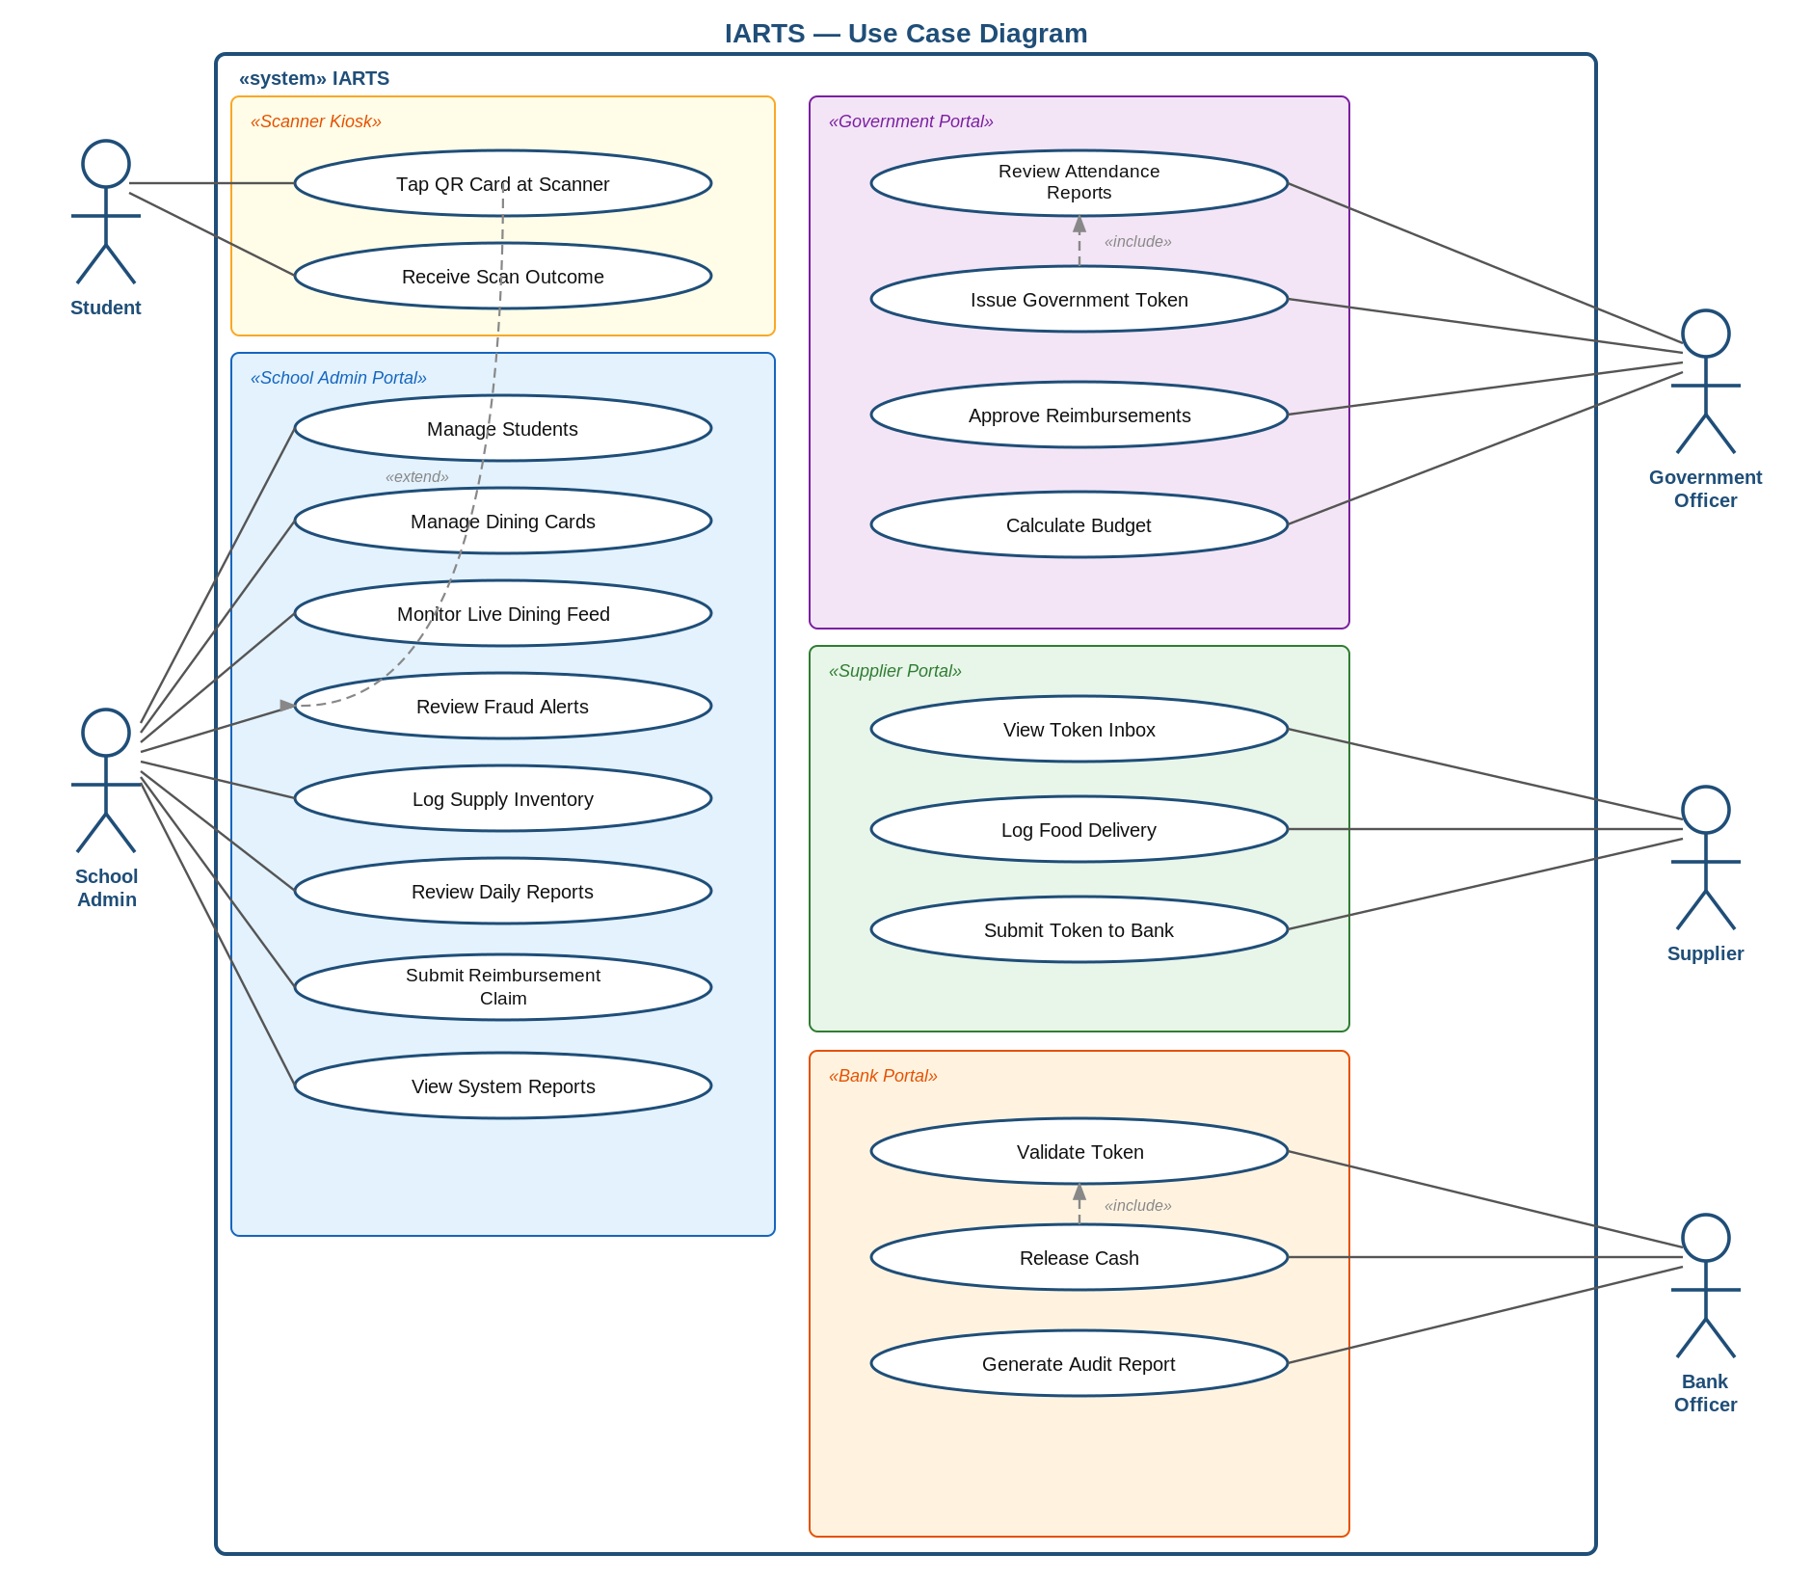
Figure 3.1: Master Use Case Diagram

3.6.2 Front-End Use Case Diagram
This view isolates the use cases that are directly triggered by a human actor through a portal or the kiosk.
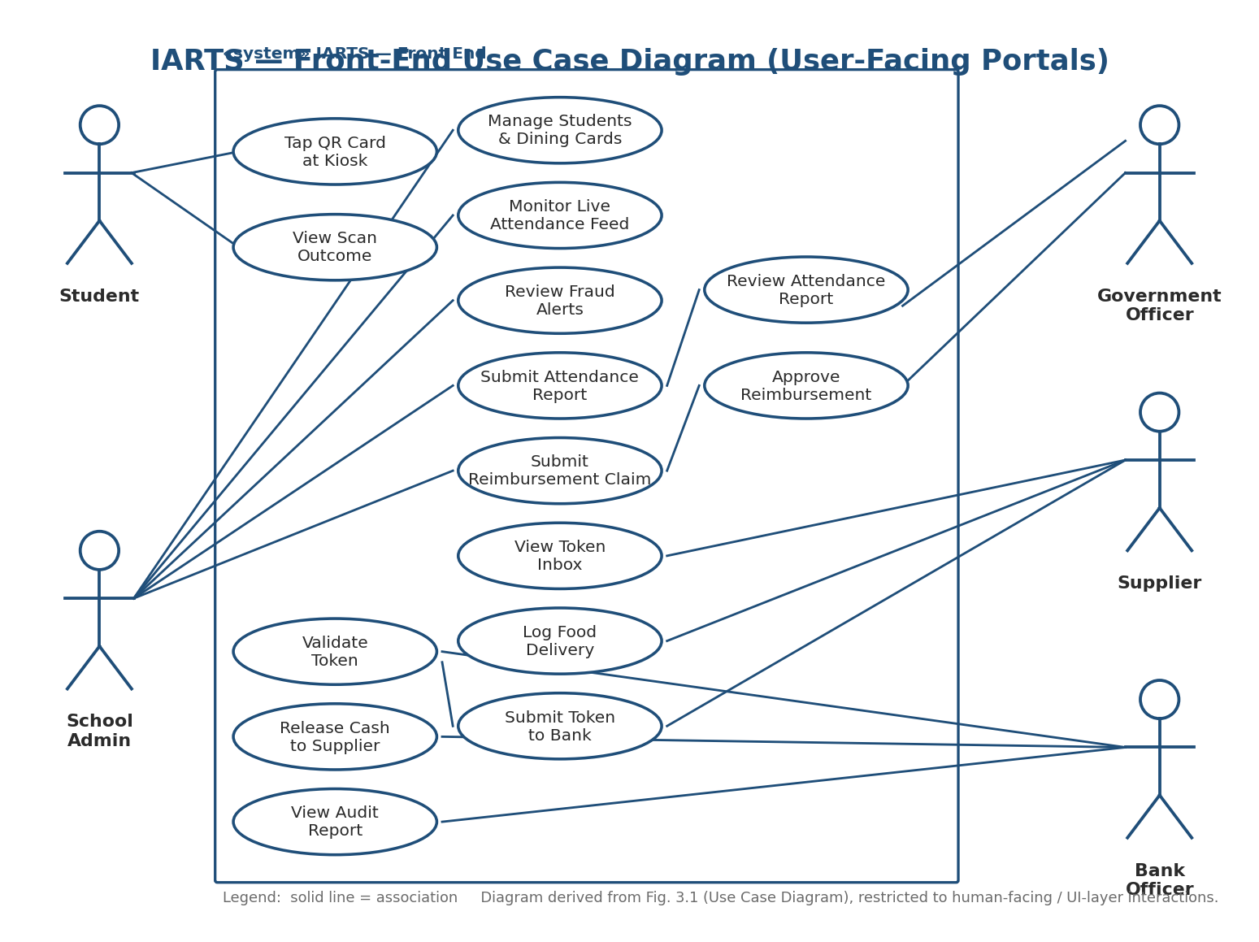
Figure 3.2: Front-End Use Case Diagram — user-facing portals and kiosk

3.6.3 Back-End Use Case Diagram
This view shows the automated, system-triggered use cases that sit behind those front-end actions — derived from the self-call loops in the sequence diagram (e.g. [validate card], [fraud analysis]) and the decision points in the activity diagram.
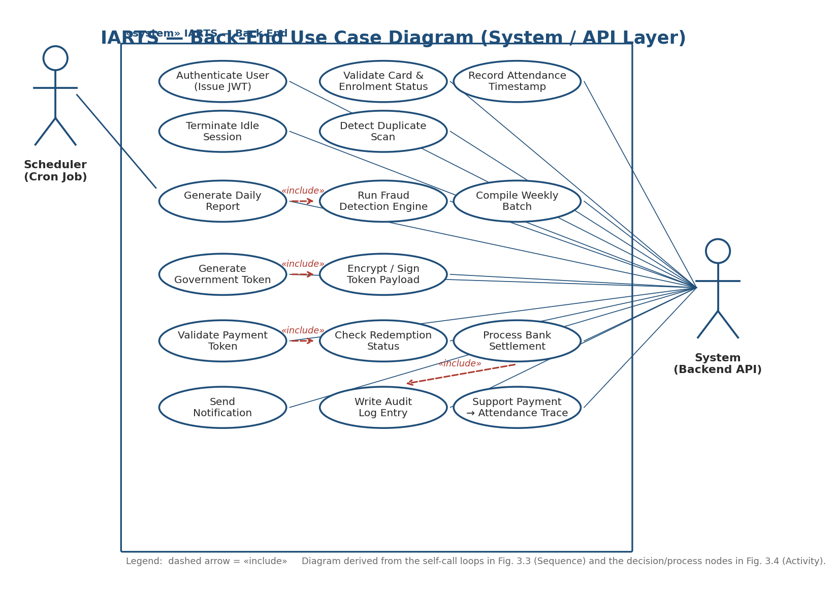
Figure 3.3: Back-End Use Case Diagram — system/API layer

3.6.4 Actor Descriptions
Actor | Role
Student | Passive actor with no login. Interacts only with the kiosk by tapping a QR dining card; triggers the Tap QR Card and View Scan Outcome use cases.
School Administrator | Registers and manages students and dining cards, monitors live attendance, reviews fraud alerts, and submits daily reports and reimbursement claims for government review.
Government Officer | Reviews attendance reports submitted by schools, approves or rejects reimbursement claims, and triggers issuance of government payment tokens.
Supplier | Receives issued tokens, logs food deliveries, and submits tokens to a bank for redemption.
Bank Officer | Validates submitted tokens and releases cash to suppliers once a token passes authenticity checks.
System (Backend API) | An internal actor representing the automated backend — validates cards, runs fraud detection, generates tokens, and writes audit logs without direct human input.
Scheduler (Cron Job) | Triggers time-based back-end processes such as end-of-day report generation and weekly batching.

3.6.5 Use Case Descriptions
Each use case shown in Figures 3.2 and 3.3 is described below, naming its primary actor and what it accomplishes.
Use Case | Primary Actor | Description
Tap QR Card at Kiosk | Student | Student presents a QR-enabled card at the dining hall scanner to begin meal verification.
View Scan Outcome | Student | Displays the result of a scan — served, duplicate, invalid, or inactive — on the kiosk screen.
Manage Students & Dining Cards | School Admin | Register, update, or deactivate student records and issue or replace dining cards.
Monitor Live Attendance Feed | School Admin | View real-time meal scans as they are recorded during service.
Review Fraud Alerts | School Admin | Inspect duplicate-scan or anomaly flags raised automatically by the system before submitting a report.
Submit Attendance Report | School Admin | Send a compiled daily attendance report to the Government Portal for review.
Submit Reimbursement Claim | School Admin | Request payment for a batch of verified daily reports.
Review Attendance Report | Government Officer | Compare a submitted report against enrolment records and historical trends.
Approve Reimbursement | Government Officer | Authorize a claim and trigger issuance of a government payment token to the supplier.
View Token Inbox | Supplier | See tokens issued by government against approved claims.
Log Food Delivery | Supplier | Record a completed delivery of meals to a school.
Submit Token to Bank | Supplier | Forward a received token to a participating bank for redemption.
Validate Token | Bank Officer | Confirm a submitted token is authentic, active, and unredeemed.
Release Cash to Supplier | Bank Officer | Disburse funds once a token passes validation.
Authenticate User (Issue JWT) | System | Verify login credentials and issue a signed session token for any human actor.
Validate Card & Enrolment Status | System | Confirm a scanned card belongs to an actively enrolled student.
Detect Duplicate Scan | System | Reject a card already used within the same meal session.
Run Fraud Detection Engine | System | Analyse a day's scans for anomalies before a report is marked claim-eligible.
Generate Government Token | System | Create a signed payment token once a claim is approved.
Validate Payment Token | System | Check token authenticity and redemption history on behalf of the Bank Officer.
Write Audit Log Entry | System | Record every attendance, approval, and payment event for traceability.

3.6.6 Class Diagram
Models the core entities of the system — User, Student, Card, MealValidation, DailyReport, ReimbursementClaim, GovernmentToken, SupplyOrder, BankTransaction, and WeeklyBatch — and how they relate to one another. This structure is also what the database design in Section 3.10.2 is derived from.
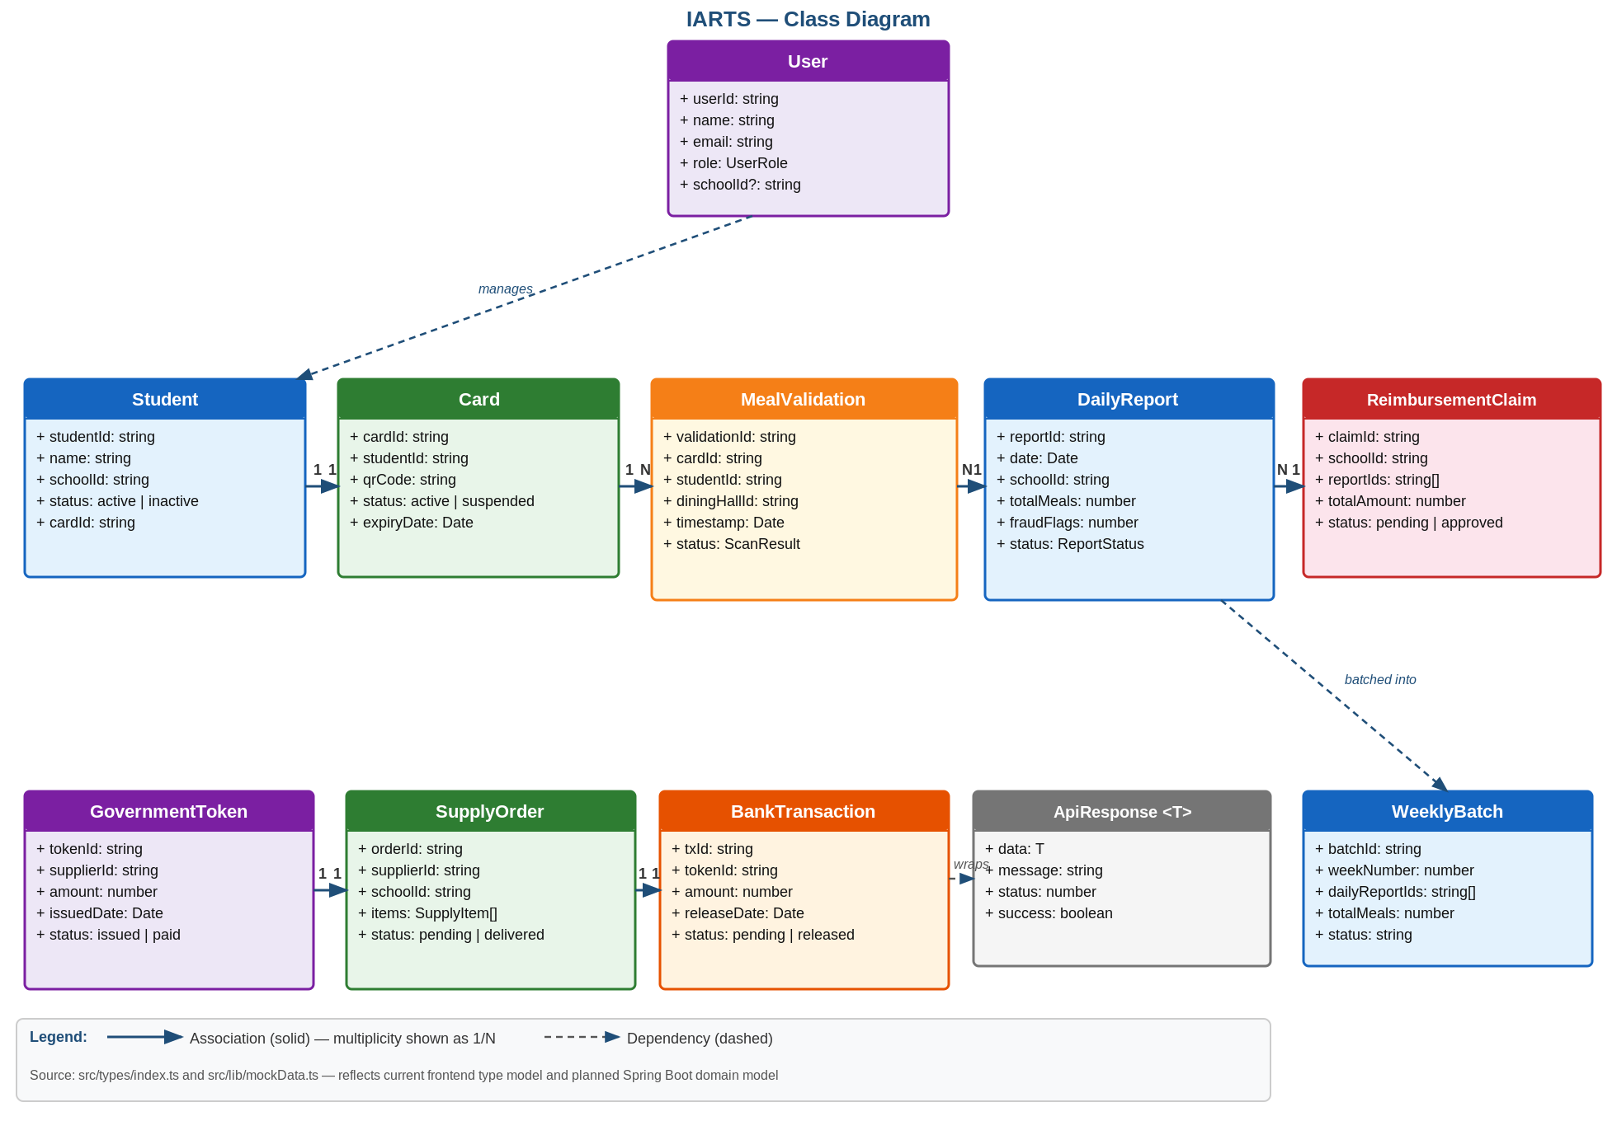
Figure 3.4: Class Diagram

3.6.7 Sequence Diagram
Walks through the full token chain: a meal scan, end-of-day report generation, government token issuance, bank settlement, and the resulting school reimbursement claim.
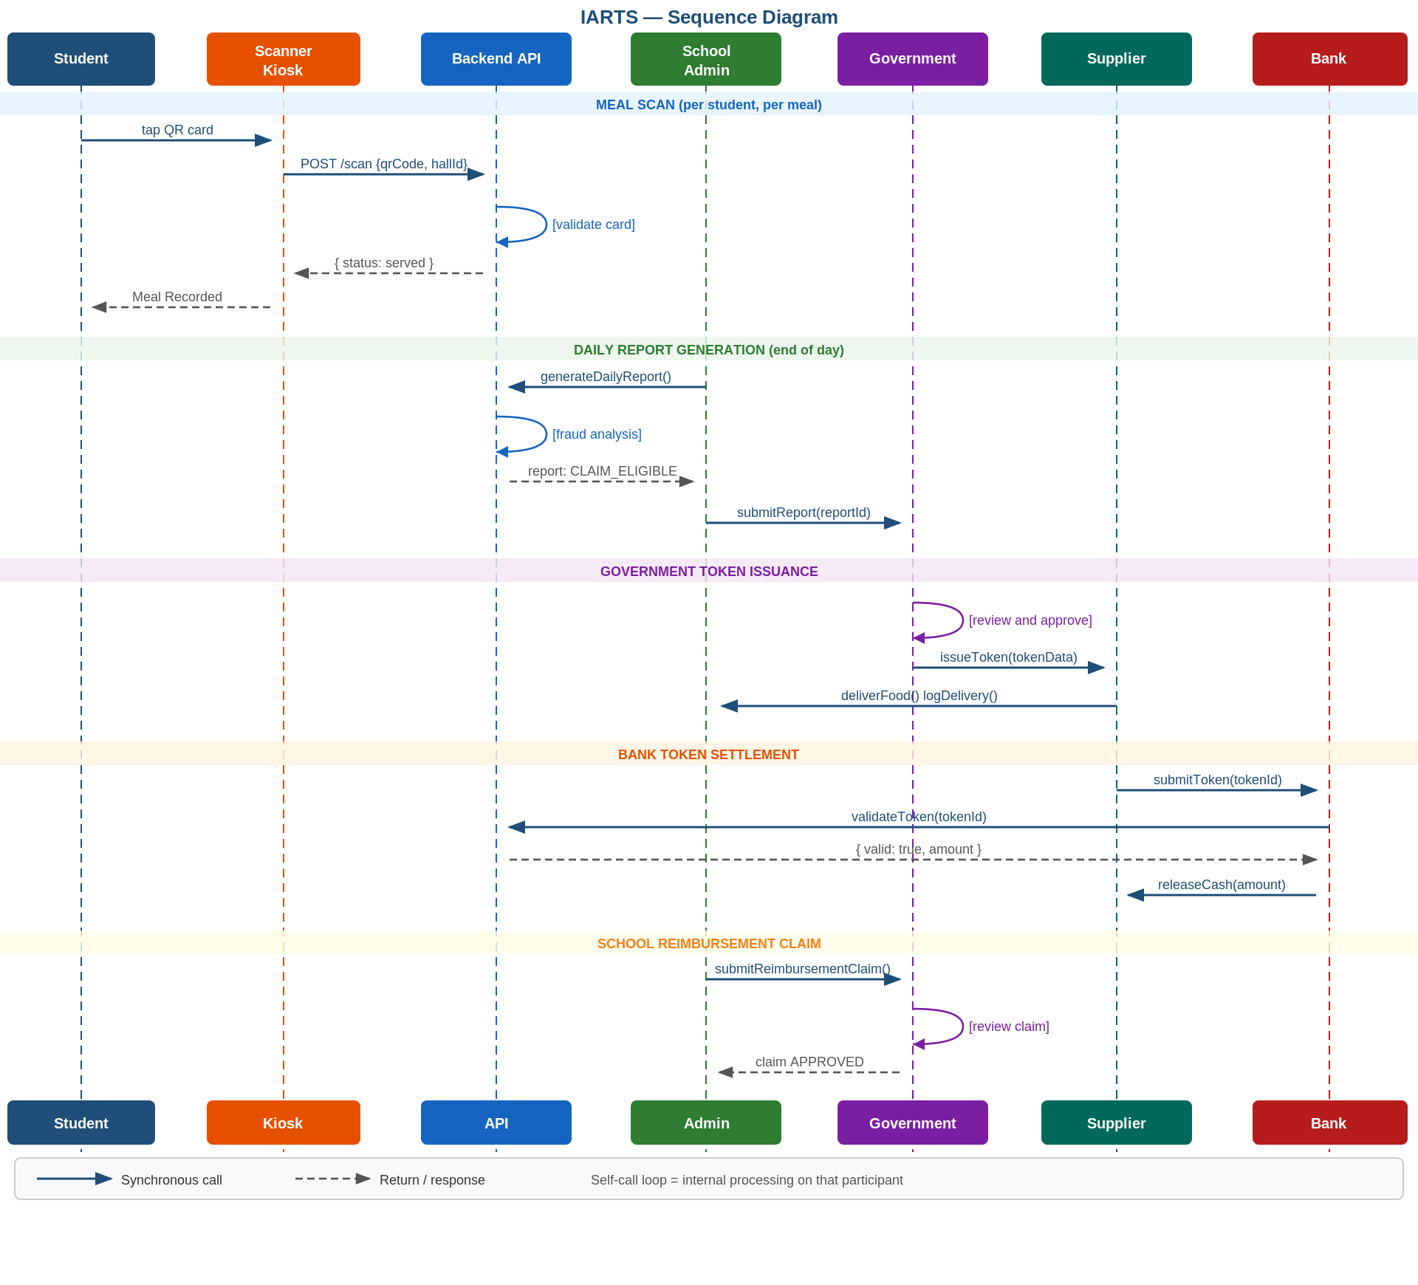
Figure 3.5: Sequence Diagram

3.6.8 Activity Diagram
Lays out the same token chain as parallel swimlanes for each portal, showing the decision points, rejection paths, and fraud-review branch that keep the process accountable end to end.
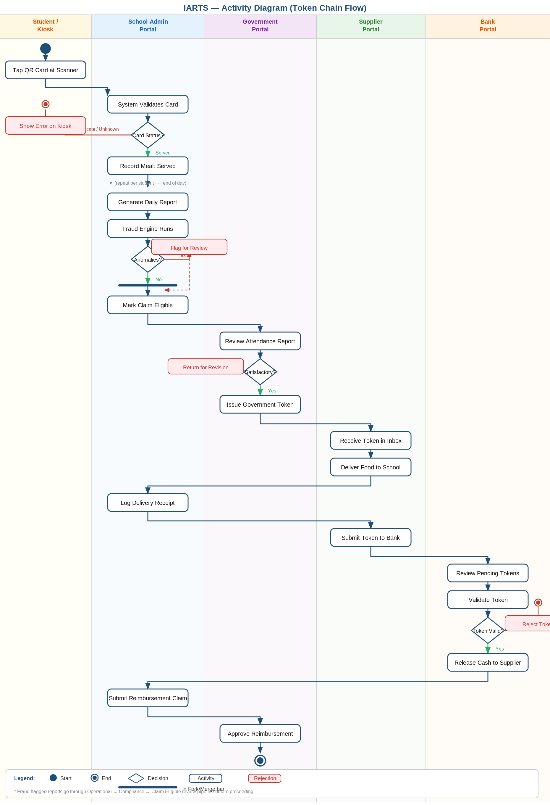
Figure 3.6: Activity Diagram — Token Chain Flow

3.7 Non-Functional Requirements
Beyond what the system must do, the following quality attributes were treated as requirements in their own right, each justified by the risk it addresses.
Requirement | Description | Justification
Security | All access is authenticated via JWT and restricted by role (RBAC); tokens are signed and validated before redemption. | Public funds and student data are involved — unauthorized access or forged tokens would directly enable fraud.
Performance | A kiosk scan must return a result in under 2 seconds under normal load. | Meal service happens in a live queue; slow feedback causes bottlenecks in the dining hall.
Reliability | The system must correctly reject duplicate or invalid scans 100% of the time. | Attendance data is the sole basis for fund disbursement, so verification cannot be allowed to fail silently.
Scalability | The backend must support many schools and concurrent kiosks without redesign. | The programme is intended to expand across multiple institutions over time.
Availability | Core scanning and reporting functions should remain available during meal hours. | An outage at meal time directly disrupts feeding and attendance capture.
Auditability | Every payment must be traceable back to the attendance records that justified it. | Accountability for government funds requires an unbroken evidence trail, not just a final balance.
Usability | Kiosk interactions require no training beyond tapping a card. | The kiosk is used daily by students, so it must be effectively self-explanatory.

3.8 Security Concepts
Because IARTS controls the release of government funds, security is not an add-on but a condition for the system to be trustworthy at all. The class diagram already reflects this: the User entity carries a role field used for role-based access control, and GovernmentToken and BankTransaction both carry a status field used to prevent re-use.
- Authentication & Authorization — every user logs in through Spring Security and receives a JSON Web Token; each request is checked against the caller's role, so a School Admin cannot approve a claim and a Government Officer cannot edit attendance data.
- Token integrity — government tokens are signed at issuance; a bank rejects any token that fails signature verification, has expired, or has already been redeemed, which is exactly the branch shown as “Reject Token” in the activity diagram.
- Duplicate-scan prevention — the kiosk and backend jointly enforce a cooldown and a per-session check so the same card cannot be counted twice at one meal.
- Separation of duties — no single role can take an attendance record all the way to a released payment; the chain always crosses School Admin → Government → Supplier → Bank.
- Session management — idle sessions are automatically terminated, and all logins/logouts are logged.
- Auditability — every meal validation, report, token, and transaction is written to an immutable audit log, so a payment can always be traced back to the attendance that justified it.

3.9 Project Methods
Software process models generally fall into two families. Plan-driven (waterfall-style) models lay out requirements, design, implementation, and testing as fixed, sequential phases — well suited to projects with stable, well-understood requirements. Agile models instead build the system in short, repeated cycles, allowing requirements and design to be revisited as understanding improves. Other recognised models — such as the Spiral model (risk-driven, cyclical refinement) and the V-Model (a plan-driven variant that pairs each development phase with a corresponding test phase) — sit between or alongside these two families but were not adopted here.

3.9.1 Chosen Model: Agile (Scrum-inspired iterative development)
IARTS was developed using an agile, iterative approach: each stage of the token chain (attendance capture, reporting, government approval, bank settlement) was designed, built, and tested as its own increment before the next was layered on.
- The requirements touched five independent stakeholder groups, so an iterative approach allowed each portal to be validated with feedback before the next was started.
- UML models (use case, class, sequence, activity) were revisited and refined between iterations rather than frozen upfront, which fits agile modelling practice better than a strict waterfall sign-off.
- Working end-to-end slices of the token chain could be demonstrated early, which suited an academic project timeline better than a single big-bang delivery at the end.

3.10 Project Design Consideration (Logical Designs)
This section presents the logical designs that sit between the requirements above and the physical implementation covered in Chapter Four: the UI wireframes and the database design.

3.10.1 UI Design
The wireframes below are low-fidelity layouts for the four main screens implied by the functional requirements and use case diagrams. They fix layout and information hierarchy before visual styling is applied.

Dining Hall Kiosk
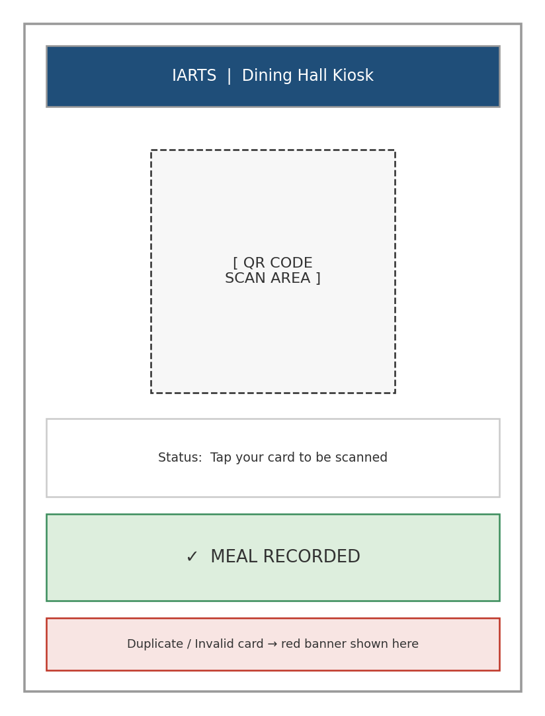
Figure 3.7: Kiosk scan screen wireframe

School Admin Dashboard
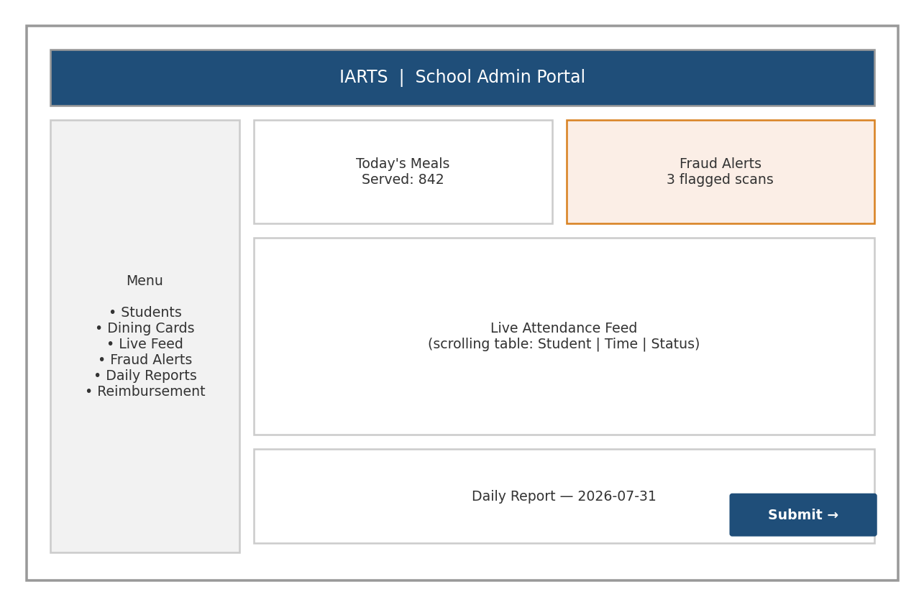
Figure 3.8: School Admin Portal wireframe

Government Officer Portal
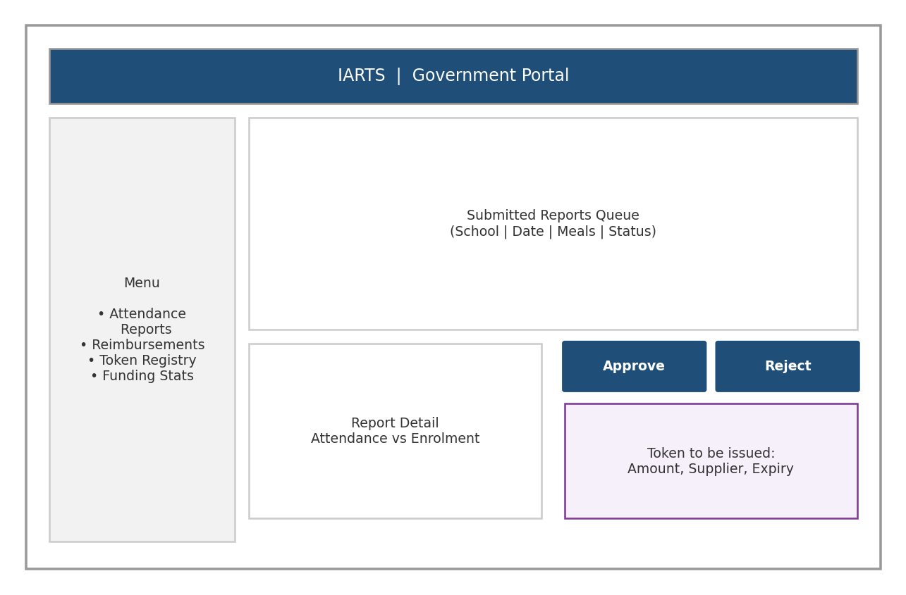
Figure 3.9: Government Portal wireframe

Supplier Portal
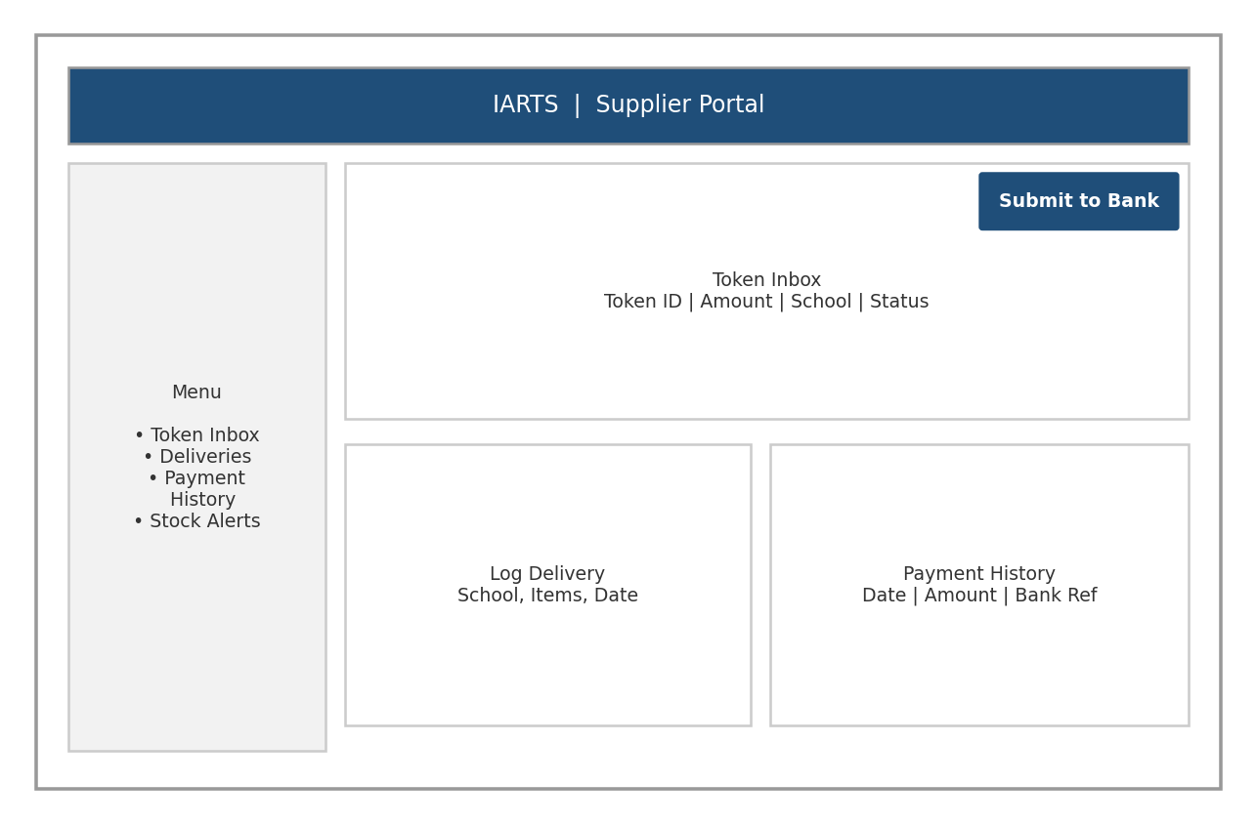
Figure 3.10: Supplier Portal wireframe (the Bank Portal follows the same layout pattern: an inbox of pending tokens plus a validate/release action)

3.10.2 DB Design
The relational schema below is derived directly from the class diagram (Figure 3.4): each class becomes a table, each attribute a column, and each association a foreign key.

Entity-Relationship Diagram
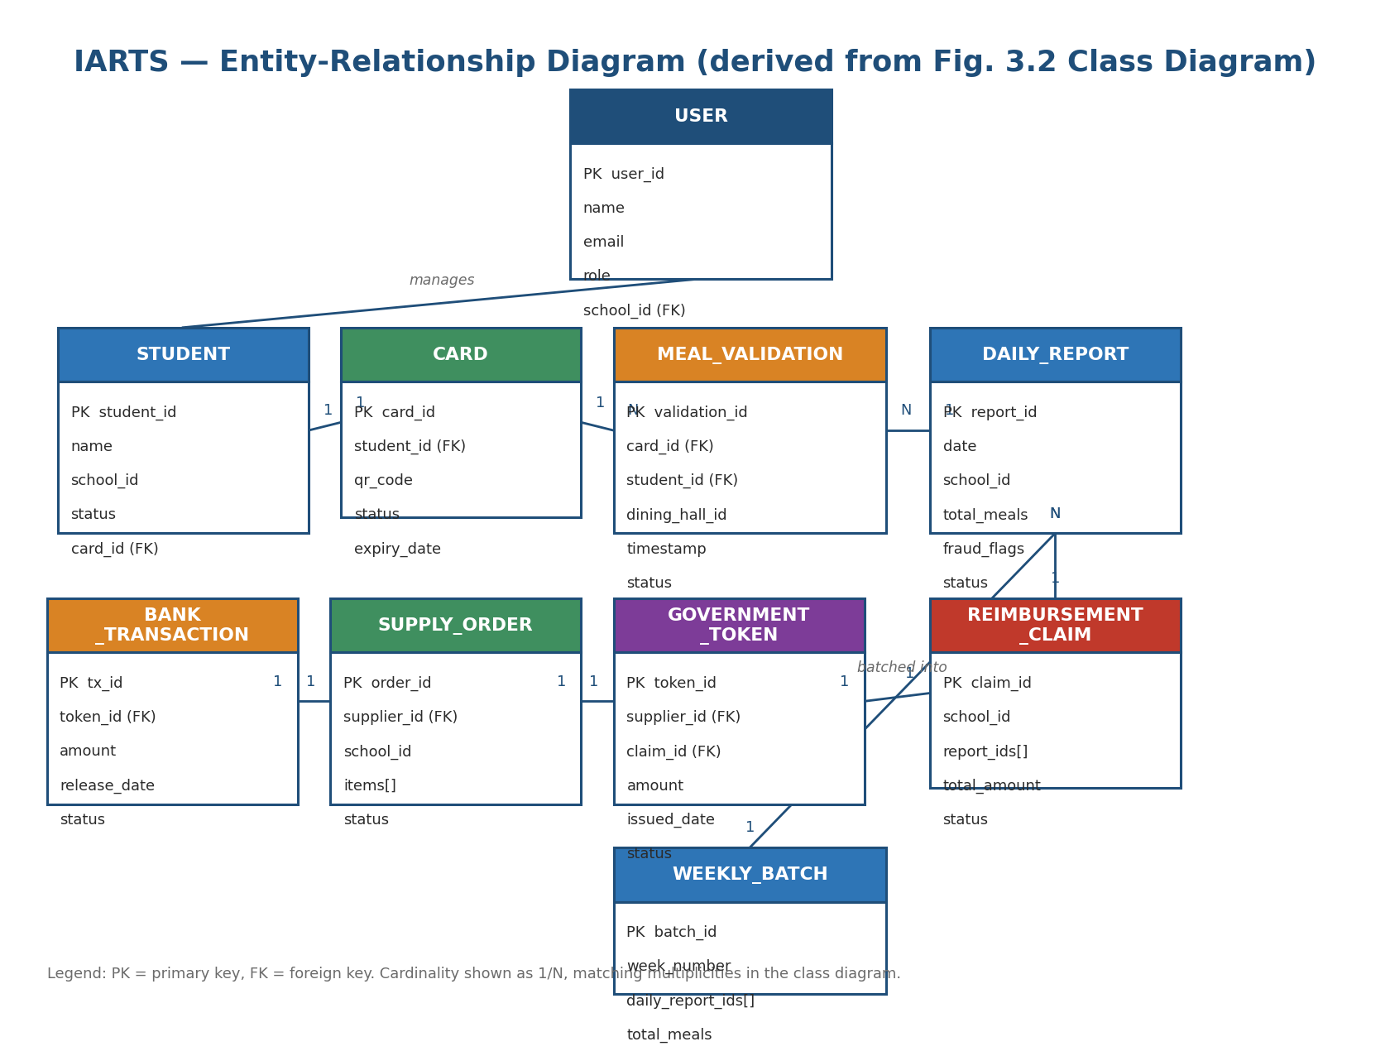
Figure 3.11: Entity-Relationship Diagram

Database Schema
Table: users
Column | Type / Constraint
id | PK, UUID
aza_user_id | VARCHAR(255), UNIQUE, NULLABLE
name | VARCHAR(255), NOT NULL
email | VARCHAR(255), NOT NULL, UNIQUE
role | VARCHAR(32), NOT NULL -- school_admin | regional_officer | financial_officer | audit_officer | supplier | bank
school_id | UUID, NULLABLE (FK: schools.id)
supplier_id | UUID, NULLABLE (FK: suppliers.id)

Table: suppliers
Column | Type / Constraint
id | PK, UUID
name | VARCHAR(255), NOT NULL
contact_email | VARCHAR(255), NOT NULL, UNIQUE
aza_api_key | VARCHAR(255), NULLABLE
aza_webhook_secret | VARCHAR(255), NULLABLE
created_at | TIMESTAMPTZ, NOT NULL

Table: students
Column | Type / Constraint
id | PK, UUID
unique_code | VARCHAR(64), NOT NULL, UNIQUE
full_name | VARCHAR(255), NOT NULL
enrollment_status | VARCHAR(32), NOT NULL -- active | inactive
school_id | UUID, NOT NULL (FK: schools.id)
year | INT, NOT NULL
department | VARCHAR(255), NOT NULL
created_at | TIMESTAMPTZ, NOT NULL

Table: cards
Column | Type / Constraint
id | PK, UUID
student_id | UUID, NOT NULL, FK: students(id)
card_number | VARCHAR(64), NOT NULL, UNIQUE
qr_code | VARCHAR(255), NOT NULL, UNIQUE
is_active | BOOLEAN, NOT NULL
issued_at | TIMESTAMPTZ, NOT NULL

Table: meal_validations
Column | Type / Constraint
id | PK, UUID
card_number | VARCHAR(64), NOT NULL
student_name | VARCHAR(255), NOT NULL
dining_hall_id | VARCHAR(64), NOT NULL
scan_time | TIMESTAMPTZ, NOT NULL
served | BOOLEAN, NOT NULL
is_duplicate | BOOLEAN, NOT NULL
is_flagged | BOOLEAN, NOT NULL
INDEX | idx_meal_validations_card_hall_time ON (card_number, dining_hall_id, scan_time)

Table: daily_reports
Column | Type / Constraint
id | PK, UUID
school_id | UUID, NOT NULL
school_name | VARCHAR(255), NOT NULL
report_date | DATE, NOT NULL
meals_served | INT, NOT NULL
enrolled_count | INT, NOT NULL
fraud_flags | INT, NOT NULL
status | VARCHAR(32), NOT NULL -- generated | operational_review | compliance_review | claim_eligible

Table: claims (V2: replaces reimbursement_claims)
Column | Type / Constraint
id | PK, UUID
claim_code | VARCHAR(64), NOT NULL, UNIQUE
school_id | UUID, NOT NULL
school_name | VARCHAR(255), NOT NULL
semester_label | VARCHAR(64), NOT NULL
semester_start | DATE, NOT NULL
semester_end | DATE, NOT NULL
verified_students | INT, NOT NULL
claim_value | NUMERIC(14,2), NOT NULL
risk_score | INT, NOT NULL
fraud_flags | INT, NOT NULL
stage | VARCHAR(32), NOT NULL
frozen | BOOLEAN, NOT NULL, DEFAULT FALSE
rejected | BOOLEAN, NOT NULL, DEFAULT FALSE
government_notes | TEXT, NULLABLE
submitted_at | TIMESTAMPTZ, NOT NULL
updated_at | TIMESTAMPTZ, NOT NULL

Table: claim_approval_logs
Column | Type / Constraint
id | PK, UUID
claim_id | UUID, NOT NULL, FK: claims(id)
action | VARCHAR(255), NOT NULL
actor | VARCHAR(255), NOT NULL
notes | TEXT, NULLABLE
created_at | TIMESTAMPTZ, NOT NULL
INDEX | idx_claim_approval_logs_claim_id ON (claim_id)

Table: claim_deductions
Column | Type / Constraint
id | PK, UUID
claim_id | UUID, NOT NULL, FK: claims(id)
reason | VARCHAR(255), NOT NULL
amount | NUMERIC(14,2), NOT NULL

Table: claim_documents
Column | Type / Constraint
id | PK, UUID
claim_id | UUID, NOT NULL, FK: claims(id)
name | VARCHAR(255), NOT NULL
type | VARCHAR(32), NOT NULL

Table: government_tokens
Column | Type / Constraint
id | PK, UUID
token_code | VARCHAR(64), NOT NULL, UNIQUE
supplier_id | UUID, NOT NULL (FK: suppliers.id)
supplier_name | VARCHAR(255), NOT NULL
institution_name | VARCHAR(255), NOT NULL
value | NUMERIC(14,2), NOT NULL
issued_date | DATE, NOT NULL
expiry_date | DATE, NOT NULL
status | VARCHAR(32), NOT NULL -- pending | active | redeemed | expired | rejected

Table: supply_orders
Column | Type / Constraint
id | PK, UUID
item_type | VARCHAR(255), NOT NULL
quantity | INT, NOT NULL
unit | VARCHAR(32), NOT NULL
order_date | DATE, NOT NULL
supplier_id | UUID, NOT NULL (FK: suppliers.id)
school_id | UUID, NOT NULL
token_ref | VARCHAR(64), NULLABLE (FK: government_tokens.token_code)
status | VARCHAR(32), NOT NULL -- pending | in_transit | delivered

Table: reorder_levels
Column | Type / Constraint
id | PK, UUID
item_type | VARCHAR(255), NOT NULL, UNIQUE
unit | VARCHAR(32), NOT NULL
current_stock | INT, NOT NULL
min_stock | INT, NOT NULL
status | VARCHAR(32), NOT NULL -- ok | low | critical

Table: bank_transactions
Column | Type / Constraint
id | PK, UUID
token_id | UUID, NOT NULL, FK: government_tokens(id)
token_code | VARCHAR(64), NOT NULL
supplier_name | VARCHAR(255), NOT NULL
amount | NUMERIC(14,2), NOT NULL
processed_at | TIMESTAMPTZ, NULLABLE
status | VARCHAR(32), NOT NULL -- pending | released | rejected

Table: payment_sessions
Column | Type / Constraint
id | PK, UUID
gov_token_id | UUID, NOT NULL, FK: government_tokens(id)
supplier_id | UUID, NOT NULL, FK: suppliers(id)
bank_transaction_id | UUID, NOT NULL, FK: bank_transactions(id)
aza_session_id | VARCHAR(64), UNIQUE, NULLABLE
amount | NUMERIC(14,2), NOT NULL
status | VARCHAR(32), NOT NULL
reference | VARCHAR(255), NULLABLE
checkout_url | VARCHAR(500), NULLABLE
created_at | TIMESTAMPTZ, NOT NULL
completed_at | TIMESTAMPTZ, NULLABLE

3.11 Development Tools
Chapter Two introduced the tools at a high level; here is how each was actually used in building IARTS.

Frontend — React 19, TypeScript, Vite, Tailwind CSS
React with TypeScript was used to build the four portals (School Admin, Government, Supplier, Bank) and the kiosk interface as typed, componentised single-page applications. Vite provided fast local rebuilds during development, and Tailwind CSS supplied the utility classes used to style layouts like the wireframes above without hand-written CSS.

State & Data — Zustand, TanStack Query, Axios
Zustand held local UI state (e.g. current logged-in role, active filters), while TanStack Query managed server data — caching attendance feeds and token lists and automatically refetching them so dashboards like the Live Attendance Feed stay current. Axios handled the underlying HTTP calls to the Spring Boot backend.

Backend — Java 21, Spring Boot, Spring Security, JWT, WebSocket
Spring Boot exposed the REST API consumed by all portals and the kiosk. Spring Security combined with JWT implemented the authentication and role-based access described in Section 3.8. WebSocket connections pushed live scan events to the School Admin's Monitor Live Attendance Feed screen without polling.

Database — PostgreSQL, Redis
PostgreSQL is the system of record for the schema in Section 3.10.2 — students, cards, reports, claims, tokens, and transactions. Redis was used as a cache and cooldown store, specifically to enforce the duplicate-scan cooldown at the kiosk without hitting the primary database on every tap.

Supporting Tools — VS Code, IntelliJ IDEA, Git/GitHub, Postman, Figma
VS Code was used for frontend development and IntelliJ IDEA for the Spring Boot backend. Git and GitHub tracked source history and supported iterative, agile-style commits per feature slice. Postman was used to manually exercise and verify API endpoints (token issuance, validation) before wiring them into the UI. Figma was used to sketch the wireframes in Section 3.10.1 before implementation.

CHAPTER FOUR
SYSTEM IMPLEMENTATION

4.1 Introduction
This chapter presents the implementation of the Institutional Accountability and Resource Tracking System (IARTS), building on the design and methodology established in Chapter Three. It covers the development environment, how the logical design was mapped onto a physical platform, the database, backend, and frontend implementations, system integration, security, testing, and the challenges encountered along the way.

4.2 Development Environment
IARTS was built using the stack introduced in Chapter Two, applied consistently across every layer of the system.
Component | Technology
Frontend | React 19 + TypeScript
Backend | Java 21, Spring Boot
Database | PostgreSQL
Cache | Redis
Authentication | JWT + Spring Security
IDE | IntelliJ IDEA (backend), VS Code (frontend)
Version Control | Git / GitHub
API Testing | Postman
UI Prototyping | Figma

4.3 Mapping Logical Design onto Physical Platform
The logical designs from Chapter Three — the wireframes and the entity-relationship diagram — were carried into the physical build through two repeatable procedures, one for UI screens and one for database tables. Each screen and each table trace back directly to a specific diagram from Chapter Three, so nothing was implemented that hadn't first been modelled.

4.3.1 UI Implementation Procedure
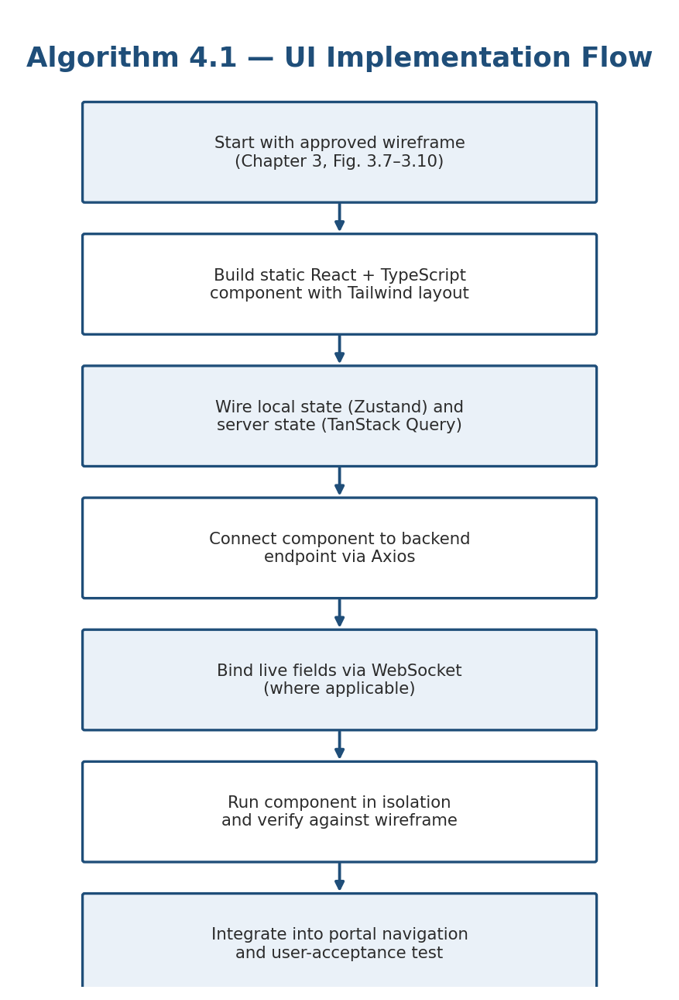
Figure 4.1: Algorithm for Implementing the UI

4.3.2 Database Implementation Procedure
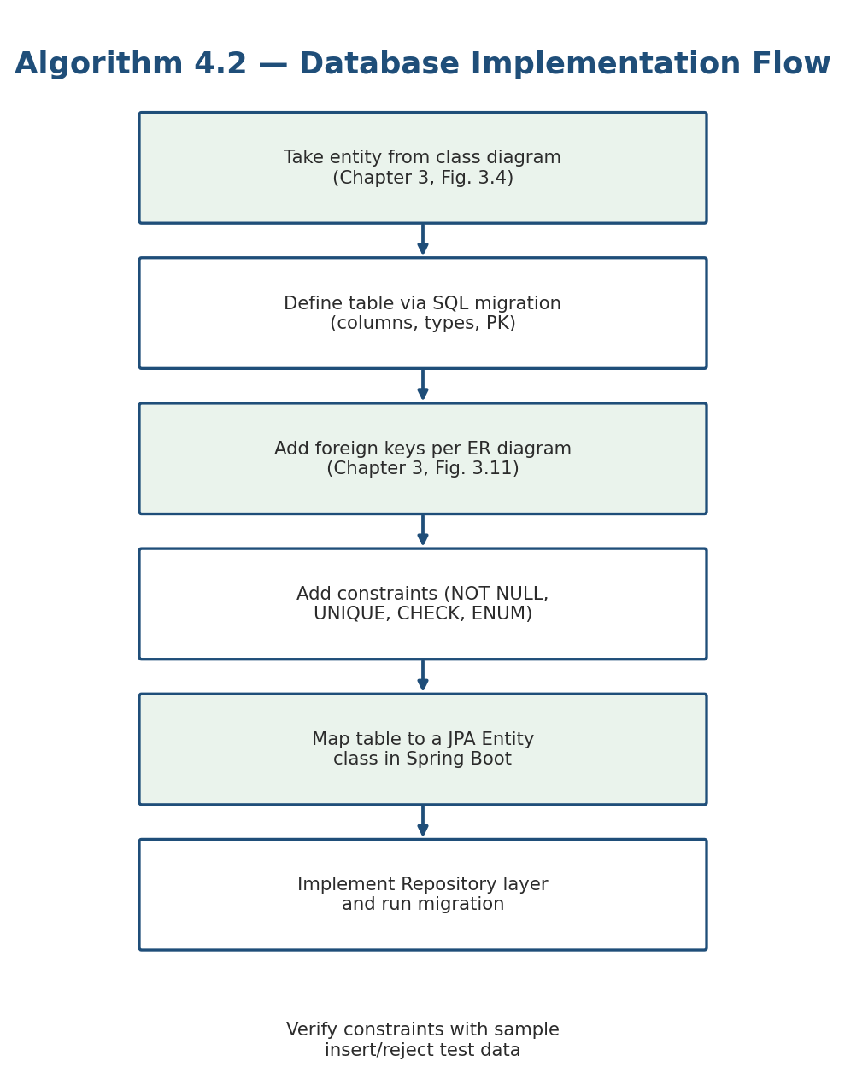
Figure 4.2: Algorithm for Implementing the Database

4.4 Database Implementation
Every table in the physical database corresponds to an entity in the class diagram and the entity-relationship diagram (Chapter Three, Figures 3.4 and 3.11). Primary keys are UUIDs, and foreign keys enforce the associations shown in those diagrams. A representative subset of the schema is shown below.
CREATE TABLE users (
user_id UUID PRIMARY KEY,
name VARCHAR(120) NOT NULL,
email VARCHAR(160) UNIQUE NOT NULL,
role VARCHAR(30) NOT NULL,
school_id UUID REFERENCES schools(school_id)
);
CREATE TABLE cards (
card_id UUID PRIMARY KEY,
student_id UUID NOT NULL REFERENCES students(student_id),
qr_code VARCHAR(64) UNIQUE NOT NULL,
status VARCHAR(20) NOT NULL DEFAULT 'active',
expiry_date DATE NOT NULL
);
CREATE TABLE meal_validations (
validation_id UUID PRIMARY KEY,
card_id UUID NOT NULL REFERENCES cards(card_id),
student_id UUID NOT NULL REFERENCES students(student_id),
dining_hall_id VARCHAR(40) NOT NULL,
scanned_at TIMESTAMP NOT NULL DEFAULT now(),
status VARCHAR(20) NOT NULL,
UNIQUE (card_id, dining_hall_id, DATE(scanned_at))
);
The UNIQUE constraint on meal_validations is what enforces duplicate-scan prevention at the database level, backing up the cooldown check performed in the QR Verification Module. Foreign keys throughout the schema use ON DELETE RESTRICT, so a student, card, or token cannot be deleted while it is still referenced by an attendance or transaction record — preserving the audit trail described in Chapter Three, Section 3.8.
[Insert Screenshot: pgAdmin / PostgreSQL table structure and sample data]

4.5 Backend Implementation
The backend is organised into modules that mirror the functional requirements from Chapter Three. Each module is a Spring Boot service backed by its own repository and REST controller.
Authentication Module
Handles login, JWT issuance and renewal, and role-based access checks on every incoming request. Built on Spring Security with a custom filter that validates the token before a request reaches any controller.
Student Management Module
Covers registration, updates, and card issuance/replacement for students; enforces uniqueness of card-to-student mapping.
QR Verification Module
Validates a scanned QR code against the card and student record, checks enrolment status, and applies the duplicate-scan cooldown.
Attendance Module
Persists each successful verification as a timestamped attendance record and feeds the live attendance feed via WebSocket.
Report Module
Aggregates a day's attendance records into a Daily Report, runs the fraud-detection checks, and compiles Weekly Batches.
Government Module
Exposes endpoints for reviewing submitted reports, approving or rejecting claims, and viewing funding statistics.
Token Module
Generates, signs, and tracks the lifecycle of Government Tokens from issuance to redemption or expiry.
Supplier Module
Manages token inbox, delivery logging, and payment history for suppliers.
Bank Module
Validates submitted tokens, checks redemption history, and records the resulting bank transaction.

Representative Code Snippets
The snippet below shows the core of the JWT authentication filter that every request passes through before reaching a controller.
public class JwtAuthFilter extends OncePerRequestFilter {
protected void doFilterInternal(HttpServletRequest req,
HttpServletResponse res, FilterChain chain) {
String token = extractToken(req);
if (token != null && jwtService.isValid(token)) {
var auth = jwtService.getAuthentication(token);
SecurityContextHolder.getContext().setAuthentication(auth);
}
chain.doFilter(req, res);
}
}
The snippet below shows the duplicate-scan check inside the QR Verification Module, which is what the UNIQUE constraint in Section 4.4 ultimately backs up.
public ScanResult verify(String qrCode, String diningHallId) {
Card card = cardRepository.findByQrCode(qrCode)
.orElseThrow(() -> new InvalidCardException());
if (!card.isActive()) return ScanResult.INACTIVE;
boolean alreadyScanned = validationRepository
.existsForCardToday(card.getId(), diningHallId);
if (alreadyScanned) return ScanResult.DUPLICATE;
validationRepository.save(new MealValidation(card, diningHallId));
return ScanResult.SERVED;
}

4.6 Frontend Implementation
Each portal was built as a set of React components consuming the backend modules above. The pages below match the wireframes presented in Chapter Three.

Login Page
Purpose: Allows any registered user (School Admin, Government Officer, Supplier, or Bank Officer) to authenticate into the system.
Features:
- Username / email field
- Password field
- Remember Me option
- Forgot Password link
[Insert Screenshot: Login Page]

School Admin Dashboard
Purpose: Central workspace for a School Administrator to manage students, watch attendance, and prepare reports.
Features:
- Student Management
- Live Scanner Feed
- Daily Reports
- Fraud Alerts
- Supply Log
[Insert Screenshot: School Admin Dashboard — see Chapter 3, Figure 3.8]

Government Dashboard
Purpose: Lets a Government Officer review submitted reports and control token issuance.
Features:
- Review Reports
- Issue Tokens
- Budget Dashboard
- Claims
[Insert Screenshot: Government Dashboard — see Chapter 3, Figure 3.9]

Supplier Dashboard
Purpose: Gives a supplier visibility into tokens owed and payments received.
Features:
- Token Inbox
- Delivery Log
- Transaction History
[Insert Screenshot: Supplier Dashboard — see Chapter 3, Figure 3.10]

Bank Dashboard
Purpose: Supports a Bank Officer in validating tokens and releasing payment.
Features:
- Validate Tokens
- Pending Tokens Queue
- Audit Reports
[Insert Screenshot: Bank Dashboard]

Scanner Kiosk
Purpose: Runs on the dining hall tablet; the only screen a Student ever sees.
Features:
- Camera / QR Scanner
- Success Screen
- Duplicate / Invalid Alert
[Insert Screenshot: Scanner Kiosk — see Chapter 3, Figure 3.7]

4.7 System Integration
The frontend and backend communicate over a conventional REST flow, with WebSocket used specifically for the live attendance feed on the School Admin Dashboard so scans appear in real time without polling.
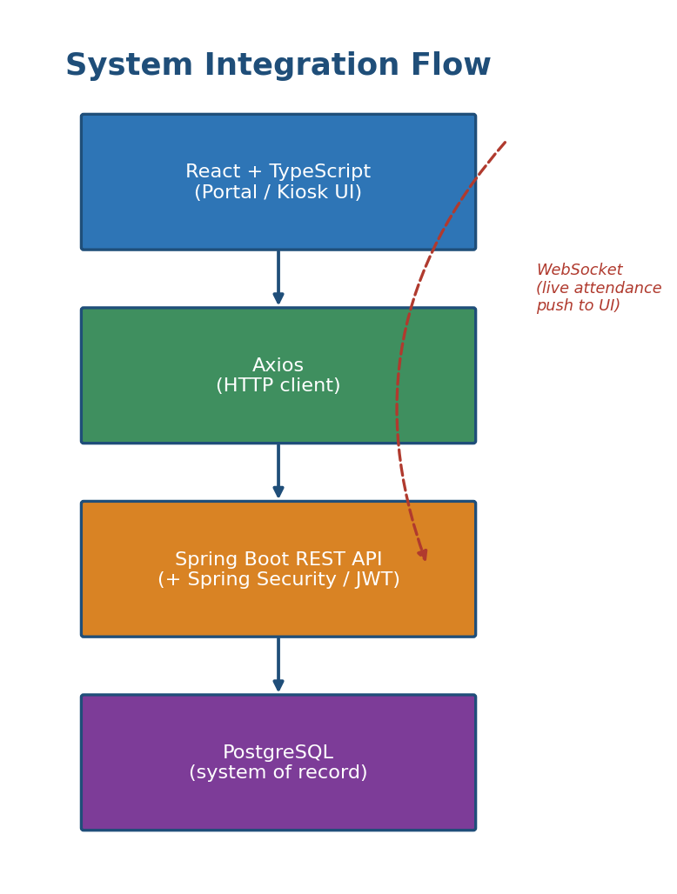
Figure 4.3: System Integration Flow
A React component calls the backend through Axios; the request reaches a Spring Boot controller, passes through the JWT authentication filter described in Section 4.5, and is served from or written to PostgreSQL. For attendance events specifically, the backend also pushes an update over a WebSocket channel that the School Admin Dashboard subscribes to, keeping the Live Scanner Feed current.

4.8 Security Implementation
- JWT Login — every session begins with a signed JSON Web Token issued at successful login and required on every subsequent request.
- BCrypt Password Hashing — passwords are never stored in plain text; BCrypt's salted hashing is used for storage and verification.
- HTTPS — all traffic between clients and the backend is encrypted in transit.
- Role-Based Access — each endpoint checks the caller's role before executing, enforcing the separation of duties described in Chapter Three.
- Terminal Key Authentication — the Scanner Kiosk authenticates with a device-level terminal key rather than a user login, since no human logs into it directly.
- Token Validation — government tokens are checked for a valid signature, non-expiry, and non-redemption before a bank releases payment.
- Audit Logging — every attendance, approval, and payment event is written to an immutable log entry for traceability.

4.9 Testing
Testing followed a plan covering component-level checks (UI and database) and system-level checks (verification and validation), before recording results against expected outcomes.

4.9.1 Component Testing
Algorithm for testing UI components:
- Render each component in isolation with mock data.
- Compare rendered output against the corresponding wireframe (Chapter 3).
- Simulate user interactions (clicks, form submission) and assert the expected state change.
- Confirm error and loading states display correctly when the API call fails or is pending.
Algorithm for testing the database:
- Run each table's migration against a clean test database.
- Insert valid sample records and confirm they persist correctly.
- Attempt inserts that violate a constraint (duplicate QR code, duplicate same-day scan) and confirm they are rejected.
- Verify that foreign-key relationships block deletion of referenced records.

4.9.2 System Testing
Algorithm for verification testing (does the system meet its specification?):
- Trace each functional requirement from Chapter Three to at least one automated test case.
- Run the full backend test suite against the token chain: scan → report → claim → token → bank settlement.
- Confirm each stage rejects invalid input exactly as specified (Section 4.9 results table).
Algorithm for validation testing (does the system meet stakeholder needs?):
- Walk a representative user from each stakeholder group through their portal end to end.
- Collect feedback against the original requirement-gathering findings (Chapter 3, Section 3.4).
- Confirm the completed token chain produces an auditable result a Government Officer would accept as proof of delivery.

4.9.3 Results
Test Case | Expected Result | Result
Valid login | Session created, JWT issued | Pass
Invalid login | Access denied | Pass
Valid QR scan | Attendance recorded | Pass
Invalid QR code | Scan rejected | Pass
Duplicate scan (same session) | Scan rejected | Pass
Inactive student card | Scan rejected | Pass
Daily report generation | Report compiled with correct totals | Pass
Reimbursement claim approval | Token generated for supplier | Pass
Token validation (valid token) | Approved for redemption | Pass
Expired / duplicated token | Redemption rejected | Pass
Role-restricted endpoint access | Request denied for wrong role | Pass

4.10 Challenges Encountered
Implementing live QR scanning
Reading a QR code reliably from a low-cost kiosk camera under variable dining-hall lighting proved inconsistent at first. This was resolved by adding client-side image pre-processing (contrast normalisation) before decoding, and a short retry loop before showing a failure state.
Managing JWT authentication across roles
Keeping five different role permissions consistent across every endpoint risked accidental over-exposure. A centralised role-check annotation was introduced so access rules are declared once per endpoint rather than re-implemented per module.
Synchronising attendance with reports
Because reports are generated at end of day while scans arrive continuously, a late-arriving scan risked being excluded from that day's report. This was resolved by closing report generation on a fixed cutoff and explicitly flagging any post-cutoff scans for the next cycle rather than silently dropping them.
Preventing duplicate scans
An early version relied on application logic alone, which occasionally allowed a race condition under near-simultaneous requests. Adding the database-level UNIQUE constraint shown in Section 4.4 closed this gap independently of the application code.
Designing the token lifecycle
Deciding when a token should be considered expired, redeemed, or invalid required aligning the Government, Supplier, and Bank modules around one shared status enum, which was settled by treating GovernmentToken.status as the single source of truth all three modules read from.

4.11 Chapter Summary
This chapter presented the implementation of IARTS, including the development environment, the mapping of logical designs onto the physical platform, the database, backend services, frontend interfaces, system integration, security mechanisms, and testing. Together, these components demonstrate that the proposed system successfully integrates attendance verification with government fund disbursement through a secure, token-based workflow, consistent with the design set out in Chapter Three.

